Relative Climate Index and Its Effect on Seasonal Tourism Demand

Hengyun Li, PhD Candidate1, Carey Goh, PhD2, Kam Hung, PhD2,   
and Jason Li Chen, PhD3

Abstract

This study proposes a relative climate index based on the push and pull theory to assess the effects of relative climate variability on seasonal tourism demand. The relative climate index measures the climatic comfort of a destination relative to that of the tourist origin. Using the proposed approach, the effects of the relative climate comfort on seasonal tourism demand are empirically tested based on a quarterly panel data set of visitor arrivals from Hong Kong to 13 major Chinese cities. The intra-annual seasonality and interannual variability are both tested in the model. The results indicate that the intra-annual relative climate positively influences tourism demand in Mainland regions, where the climate is significantly different from that of Hong Kong.

Keywords

relative climate index, seasonal tourism demand, intra-annual effect, interannual effect

Introduction

Seasonality in tourism demand has been posing enormous challenges to tourism destinations and should be handled and analyzed carefully (Goh 2012). Baum and Lundtorp (2001) stated that tourism seasonality is one of the most consistently vexing policy issues. Seasonality significantly affects various aspects of the tourism economy (especially in high latitude regions), such as labor markets that are destabilized by temporal employment, tourism resources underutilization, marketing (packaging, distribution, and pricing), and other areas of operations (Baum and Lundtorp 2001; Koenig-Lewis and Bischoff 2005). Therefore, seasonality is a critical issue that should be addressed at policy, marketing, and operation levels.

Natural seasonality is one of the most important factors causing seasonal tourism demand (Baron 1975;Butler 1994; Koenig-Lewis and Bischoff 2005). Natural seasonality is determined by the climate elements, such as temperature, precipitation, humidity, wind, and sunshine. Tourists may be more likely to visit a warm destination when they are experiencing a cold winter in their origin country. In the meanwhile, winter activities could be attractive to those who live in a warm place.

The forces behind the seasonality in tourist flows must be properly analyzed to help the host country improve its utilization of tourism resources and optimize its productivity and economic performance. Yu, Schwartz, and Walsh (2010) argued that the dynamic nature of the seasonal pattern of both tourism demand and climate is important and should not be neglected. However, practitioners in the tourism industry tend to consider climate as a given, thereby hindering the studies on the climate issue and publication of associated policies (Eugenio-Martin and Campos-Soria 2010). It has been found that many tourism demand studies have disregarded the climate factor because it was deemed to be obvious or beyond the control of managers, or because it was regarded as constant (Amelung, Nicholls, and Viner 2007; Berrittella et al. 2006; Yu, Schwartz, and Walsh 2010).

In the literature, climate variables have been used to explain seasonal tourism demand and destination choices (Bigano, Hamilton, and Tol 2006; Goh, Law, and Mok 2008; Maddison 2001). Kulendran and Dwyer (2012), Yu, Schwartz, and Walsh (2010), Goh (2012), and Becken (2013) showed that climate variation has a significant influence on the seasonal tourism demand. Moreover, Hadwen et al. (2011) found that climate is a driver of seasonal tourism demand across multiple climate zones, which reaches a more general understanding of the role of climate in tourism seasonality. However, most of these studies focused only on destination climate, underpinned by the theoretical framework of Frechtling (1996)andButler (1994) that treats climate as a pull factor. On the other hand, researchers have also evaluated the effects of home climate as a push factor on tourism demand (Eugenio-Martin and Campos-Soria 2010; Saverimuttu and Varua 2014) based on Koenig-Lewis and Bischoff’s (2005) study.

However, climate has rarely been treated as both push and pull factors simultaneously in the literature. As novelty seeking is a key motivation to travel, Lee and Crompton (1992) and Pearce (1987) contended that most people are interested in experiencing something different, as many of their needs cannot be met at home. Similar to the relative price of tourism, the comfort level brought by climate or weather must be considered in relative terms. Both the origin and destination climates are found to affect the timing of travel and, thus, cause seasonality in tourist arrivals (Goh 2012; Lim and McAleer 2001). Therefore, it is important to assess the effects of climate difference between origins and destinations reflecting the role of climate as both push and pull factors (Hamilton, Maddison, and Tol 2005; Scott, McBoyle, and Schwartzentruber 2004).

Moreover, the existing studies considering both destination and origin climates have only tested the effects of individual climate indicators such as temperature and precipitation (Zhang and Kulendran 2016; Li, Song, and Li 2016). Neglecting the combined effects of different climatic variables may distort the real climatic situation (Mieczkowski 1985). According to de Freitas (2003, 2005), climate is multifaceted, and tourists understand and respond to a particular climate condition based on an integrated weather environment. Therefore, climate elements need to be appropriately aggregated to measure the integrated influences and to allow the comparison across destinations and origins (de Freitas 2005; de Freitas, Scott, and McBoyle 2004, 2008).

The effects of climate variability can be separated into intra-annual seasonality and interannual variability (Becken 2013). The intra-annual seasonality is the effects of short-term weather variation from quarter to quarter. In the meanwhile, it is necessary to control the effects of interannual variability caused by the deviation of climate from its long-term trend. For example, a particularly warm winter in the destination compared to average years might contribute to an increased or decreased tourist arrivals. However, most extant studies did not distinguish the effects of intra-annual seasonality and interannual climate variation on tourism demand. Consequently, the findings from prior literature would be a mixed effect including both intra- and interannual climate variations.

To fill the gap in the literature, the current study aims to construct a uniform index under the push–pull framework to gauge the relative climate comfort between the destination and the origin. Using the proposed approach, the interannual and intra-annual effects of the relative climate comfort on seasonal tourism demand are empirically tested based on a quarterly panel data set of visitor arrivals from Hong Kong to 13 major Chinese cities. The panel data modeling technique is applied in this study, as Hsiao (2003) indicated that the use of panel data has several advantages over time series or cross-section data, including a greater degree of freedom, the mitigation of multicollinearity, and a reduction in omitted variable bias.

Literature Review

Effects of Destination Climate Variability on Seasonal Tourism Demand

By using statistical models, Agnew and Palutikof (2006) analyzed the effect of climate variability, including both intra- and interannual scales, on the UK tourism demand. The results showed that the United Kingdom’s outbound tourism demand is highly sensitive to climate variability within the preceding year, while the UK’s domestic tourism demand is exceptionally sensitive to climate variability within the travel year. Goh (2012) included a monthly climate index into a commonly used tourism demand model and found that destination climate variability significantly affects seasonal tourism demand from major source markets to Hong Kong. Nunes et al. (2013) measured seasonal climate by breaking down key climate variables into two parts: maximum summer temperature and minimum winter temperature. They then estimated the effects of these variables on tourism demand. Increases in maximum temperature during the summer lead to a sizable decline in the number of domestic tourists, while temperature is insignificant for international tourists, thus signaling a higher resilience of this type of demand. The possible reason for this is that domestic and foreign tourists from Tuscany appear to be drawn by different types of attractions. Moreover, Becken (2013) analyzed the effects of weather in terms of intra-annual seasonality and interannual variations in the Westland, New Zealand. Regression analysis showed that seasonality in Westland is significantly affected by intra-annual seasonal weather, while the influence of interannual weather variations is insignificant. Specifically, seasonal tourism flows in Wetland is largely driven by temperature, while rainfall and sunshine hours are insignificant factors. A warmer summer is associated with more visitor nights, while colder winter months are correlated with fewer tourists. Recently, Zhou-Grundy and Turner (2014) argued that sunshine is a useful precursor in modeling China’s regional tourism demand; however, the authors pointed out that the greatest limitation in this study is that data are annual and not seasonal. Seasonal regional data can produce more accurate forecasts as the regions in China vary greatly in terms of weather conditions.

Different from the above studies, some studies extract the seasonal components of the data before conducting the formal analysis. Via decomposing the data into a seasonal component and a stochastic trend, Yu, Schwartz, and Walsh (2010) used univariate regression to estimate the influence of seasonal components of climate on tourism demand for the Denali National Park in Alaska and the Everglades in Florida, and found that climate is an important factor in determining both places’ seasonal tourism demand. By using tourism flows from the United States, United Kingdom, Japan, and New Zealand to Australia, Kulendran and Dwyer (2012) applied a new method to examine the effects of climate on seasonal variation in tourism. First, the seasonal component in tourist arrivals to Australia was extracted by using the Basic Structural Model (BSM) approach. Second, the deviation between climate variation and seasonal variation of tourism flows were measured by using the Euclidean minimum distance approach. Finally, time-series modeling was applied to investigate the effects of climate variables on seasonal tourist arrivals. It was found that maximum temperature, relative humidity, and sunshine hours shape the seasonal tourism demand variation, but this effect varies across seasons and origin countries. Similarly, by extracting the seasonal factors via Census X-12 decomposition method, Ridderstaat et al. (2014) investigated how seasonal climate factor affects seasonal tourism flows in small island countries, specifically from the United States and Venezuela to Aruba. Panel data regression showed that the climate factors of wind speed and cloud coverage in Aruba are important pull factors in shaping the seasonal tourism demand from the United States, while temperature and rainfall in Aruba are significant determinants for seasonal tourism demand from Venezuela.

Other studies include both climate factor and institutional factor to explain seasonal tourism demand. Using the rough sets approach, Goh, Law, and Mok (2008) examined Hong Kong’s tourist arrivals from the United States and United Kingdom by considering destination climate and leisure time as determinants. The researchers concluded that both determinants are more influential than economic factors in explaining the variability of monthly tourist arrivals. Moreover, based on the data in eastern Australia, Hadwen et al. (2011) examined the impacts of natural and institutional factors on tourism seasonality, and it was found that climate is the most important factor driving tourism seasonality in equatorial, tropical, grassland, desert, and temperate zones; however, the tourist arrivals in alpine/subalpine areas is affected by both natural and institutional factors, and institutional factors drive the subtropical climate zone.

Several studies on climate change have analyzed the effects of destination climate variability on seasonal tourism demand. Bigano et al. (2005) argued that, except for the regions developing winter sports, temperature is the most important factor for domestic tourism and positively affects tourism demand in the same months across Europe. Based on panel-data modeling technique, the results of Taylor and Ortiz’s (2009) research determined significant effects of all monthly climate variables and their lags, including sunny conditions, temperature, and precipitation, on seasonal domestic tourism demand in the United Kingdom. In addition, Moore (2010) for the first time constructed the relative seasonal tourism climatic indices (relative to competitors) and applied a cross-country tourism demand model to analyze the demand issues in the Caribbean destinations. The results showed that changes in relative seasonal tourism climatic indices could lead to substitution away from that destination.

Effects of Origin/Home Climate Variability on Seasonal Tourism Demand

Tourism patterns can also be influenced by the climate conditions of origin markets. However, it was found that only three empirical studies have tested the influence of home climate on domestic or international tourism demand.

By applying a bivariate probit model and geographical information system analysis, Eugenio-Martin and Campos-Soria (2010) developed a new regional tourism climate index based on a double-hurdle model of temperature and rainfall, and found that residents in the countries with more comfortable climate are more likely to have domestic travel rather than international travel, which means home climate is an important determinant of the holiday destination choice between domestic and international. Similarly, climate variability in the origin country, that is, the United States, was a significant “push factor” for tourists traveling to Philippines (Saverimuttu and Varua 2014). The results indicated that the number of US tourists in Philippines increase significantly when the former experiences a cold season. Moreover, to explain seasonal tourism flow from the United States and Venezuela to Aruba, empirical findings of Ridderstaat et al. (2014) showed that the climate factors of rainfall, temperature, and wind speed are key push factors in the case of the United States, while rainfall is a significant push factor in Venezuela.

The literature on the effects of destination and origin climate variability on seasonal tourism demand are summarized in Table 1.

The existing studies have rarely tested the interaction effect of destination climate and origin climate variability on tourism demand with only two exceptions. Zhang and Kulendran (2016) applied the time-series modeling approach to measure the impact of economic factors and climate variables, including climate variables in Hong Kong, temperature in the tourist’s country of origin, and temperature in Singapore (a substitute destination), on the seasonal variation of inbound tourism demand in Hong Kong. The results showed that relative temperature (destination temperature/tourist origin country temperature) has a significant effect on tourist flows from Mainland China, Taiwan, and Japan to Hong Kong, while both relative temperature and destination humidity has significant effect on tourist flows from South Korea to Hong Kong. However, other climate factors, including destination (Hong Kong’s) rainfall, humidity, visibility, number of tropical cyclones, number of thunderstorms, and the temperature in substitute destination of Singapore exhibit insignificant effects. Making a further step on this topic, Li, Song, and Li (2016) not only tested the effect of relative temperature (between destination climate and source market) on tourism demand but also examined the effects of other relative climate indicators, including relative maximum temperature, relative minimum temperature, relative average temperature, relative average humidity, relative average precipitation, and relative average hours of sunshine.

**Table 1.** Literature Summary by Ascending Order.

|  |  |  |  |  |  |  |  |  |  |
| --- | --- | --- | --- | --- | --- | --- | --- | --- | --- |
|  | Author | Ref date | Journal Name | Title | Data Type | Method and Model | Region Focused | Dependent Variable | Climate Index |
| Destination climate and tourism demand | Bigano et al. | 2005 | *FEEM Working Paper No. 30.05* | The effect of climate change and extreme weather events on tourism | Monthly data | (1) Mail and telephone surveys; (2) econometric model (panel data) | (1) Europe; (2) mainly focus on Italy | Number of bed-nights, and tourist arrivals for both domestic and foreign tourism | (1) Temperature, lagged (t-1, t-12); (2) precipitation, lagged (t-1, t-12); (3) dummy variables (to capture the effect of extreme seasons on dependent variables) |
| Agnew and Palutikof | 2006 | *Climate Research* | Impacts of short-term climate variability in the United Kingdom on demand for domestic and international tourism | Monthly data | Regression model | United Kingdom | Domestic tourism demand (monthly tourist nights) | Same-month central England temperature |
| Goh, Law, and Mok | 2008 | *Journal of Travel Research* | Analyzing and forecasting tourism demand: A rough sets approach | Monthly data | Rough sets approach | Long-haul US and UK tourism demand for Hong Kong | Inbound tourist arrivals | TCI |
| Taylor and Ortiz | 2009 | *Tourism Economics* | Impacts of climate change on domestic tourism in the United Kingdom: a panel data estimation | Monthly data | Econometric model (panel data) | United Kingdom | Domestic tourism demand, including trips, bed nights, and expenditures | (1) Temperature; (2) sunny hours |
| Kulendran and Dwyer | 2010 | *CRC for Sustainable Tourism Pty Limited* | Seasonal variation versus climate variation for Australian tourism | Quarterly data | Time series model | Tourism flows from the United States, United Kingdom, Japan, and New Zealand to Australia | Inbound tourist arrivals | (1) Maximum temperature; (2) relative humidity; (3) sunshine hours |
| Moore | 2010 | *Current Issues in Tourism* | The impact of climate change on Caribbean tourism demand | Monthly data | Econometric model (panel data) | Caribbean islands | Inbound tourist arrivals | Relative TCI (relative to competitors) |
| Yu, Schwartz, and Walsh | 2010 | *Journal of Tourism* | Climate change and tourism seasonality | Monthly data | Univariate regression analysis | Denali National Park in Alaska and the Everglades in Florida | Seasonal component of number of visitors | A climate index integrating whether elements of rain, including lightning, hail, and snow |
| Hadwen et al. | 2011 | *Tourism Geographies* | Do climatic or institutional factors drive seasonal patterns of tourism visitation to protected areas across diverse climate zones in eastern Australia? | Monthly data | Regression model | 23 protected areas across six Koppen climate zones in eastern Australia | Number of campers; number of vehicles; number of visitors; number of visits | (1) Rainfall; (2) minimum temperatures; (3) maximum temperature |
| Goh | 2012 | *Annals of Tourism Research* | Exploring impact of climate on tourism demand | Monthly data | Time-series model (error correction model) | From United States, United Kingdom, Japan, and China to Hong Kong | Inbound tourist arrivals | TCI |
| Becken | 2013 | *Journal of Travel Research* | Measuring the effect of weather on tourism: a destination-and activity-based analysis | Monthly data | Regression model | Westland in New Zealand | Visitor nights | (1) Temperature; (2) sunshine hours; (3) rainfall |
| Nunes et al. | 2013 | *International Journal of Ecological Economics and Statistics* | An econometric analysis of climate change impacts on tourism flows: an empirical evidence from the region of Tuscany, Italy | Annual data | Econometric model (panel data) | Tuscany's 254 municipalities | Domestic and foreign arrivals | (1) Maximum summer temperature; (2) Minimum winter temperature |
| Ridderstaat et al. | 2014 | *Tourism Management* | Impacts of seasonal patterns of climate on recurrent fluctuations in tourism demand: evidence from Aruba | Monthly data | Econometric model (panel data) | Tourism demand from the United States and Venezuela to Aruba | Seasonal factors of number of visitors | (1) Rainfall; (2) temperature; (3) wind speed; (4) cloud coverage |
| Home Climate and Tourism Demand | Eugenio-Martin and Campos-Soria | 2010 | *Tourism Management* | Climate in the region of origin and destination choice in outbound tourism demand | Annual data | A bivariate probit model (GIS and nonparametric techniques are also used to estimate) | European areas | Choice of traveling domestically or abroad | A new regional tourism climate index based on a double-hurdle model of temperature and rainfall |
| Saverimuttu and Varua | 2014 | *Asia Pacific Journal of Tourism Research* | Climate variability in the origin countries as a “push” factor on tourist arrivals in the Philippines | Quarterly data | Time series model (OLS estimation) | From the United States to Philippines | Inbound tourist arrivals | Southern Oscillation Index (SOI) |
| Ridderstaat et al. | 2014 | *Tourism Management* | Impacts of seasonal patterns of climate on recurrent fluctuations in tourism demand: evidence from Aruba | Monthly data | Econometric model (panel data) | Tourism demand from the United States and Venezuela to Aruba | Seasonal factors of number of visitors | (1) Rainfall; (2) temperature; (3) wind speed |

Note: TCI = tourism climate index; OLS = ordinary least squares.

Although the individual effects of a range of climate indicators can be tested with the method used in the previous studies, it can be argued that the relationship between climate indicators and tourism demand might be nonlinear. For example, when the temperature rises beyond the optimum level, its effects may change direction. The significance of individual indicators may vary from case to case, which causes difficulty in the selection of climate indicators when applying this approach to other contexts. Hence, this study aims to develop a relative climate index measuring relative climate comfort that avoids the potential nonlinear issue. Both push and pull factors are reflected in the index. With the uniform nature, the proposed approach does not suffer from potential multicollinearity issues and is readily applicable to other contexts to analyze seasonal tourism demand.

Construction of Relative Tourism Climate Index

Climate results from complex interactions among various climatic variables, such as temperature, precipitation, wind speed and humidity, which should be used to construct a climate index appropriate for the tourism context. Mieczkowski (1985) developed a tourism climate index (TCI) as a quantitative measurement of tourism climate via combining several tourism-related climate factors into a single index. The variables in the TCI formula are weighted according to the relative importance they are believed in an “average” tourist’s well-being visiting a particular location at a particular time, relying primarily on the expert judgment, observation, and experience of geography researchers. The TCI has been one of the most cited and widely recognized climate indices to assess destination climate comfort and attractiveness (Denstadli, Jacobsen, and Lohmann 2011). In the meanwhile, some limitations of this index have been pointed out (de Freitas 2005; de Freitas, Scott, and McBoyle 2008). First, the choices of some elements and their weighting rely primarily on arbitrary and subjective value judgments of the researcher. Second, this measure has been secondarily derived and interpreted without field investigation. Mieczkowski (1985) was also aware of these limitations but argued that the final scores of the TCIs should not be regarded as mathematically precise, instead they are reasonable approximations at best. Although de Freitas, Scott, and McBoyle (2008) addressed the deficiencies by devising a theoretically sound and empirically tested Climate Index for Tourism (CIT), which is also called the second generation of TCI. However, the CIT is designed for a specific type of tourism, that is, 3S (sun, sea and sand) tourism, based on survey data rather than on climatic statistics. Since one of the objectives of this study is to empirically test the effects of relative climate, it is effective to use secondary data to cover a wider range of destinations and all types of tourism. Therefore, this study applies one of the most cited and recognized climate indices developed by Mieczkowski (1985).

The TCI can be calculatedusing multiple climatic variables. Each climatic variable is firstly rated as a score using a rating system proposed by Mieczkowski (1985), and then the final TCI is defined as follows:

, (1)

where  is the rated score of maximum daily temperature,  is the score of minimum daily relative humidity,  is the score of mean daily temperature,  is the score of daily relative humidity,  is the score of precipitation,  is the score of daily duration of sunshine,  is the score of wind speed,  represents the travel origin market or destination, and  represents time.

On the basis that seeking novelty is a key motivation to travel, a relative tourism climate index (Rtci) can be constructed as  to measure the climate difference between the origin and the destination, where *Dtci* is the destination tourism climate index, and *Otci* is the origin tourism climate index. It has been found that tourists may visit destinations in what could be perceived as less comfortable climate conditions compared to where they live because of their motivation to seek different experience in a climate that differs from home (Jacobsen 2001). This suggests that the relative difference should be taken as the absolute value, because both positive and negative differences in climate would be considered as novelty for tourists. This specification is also supported in the empirical study, where the relationship between visitor arrivals and RCI is found mirrored across the zero value of . After taking absolute value, both positive and negative values of  fit reasonably well into a single linear relationship with visitor arrivals. The constructed RCI can be used to account for the intra-annual   
effects of short-term weather variation from quarter to quarter.

To assess the interannual effects of climate variability, the interannual relative climate index is defined as the deviation of  from its long-term average, which is calculated as , where  and  are calculated as the six-year average of  and  for each quarter in the empirical study.

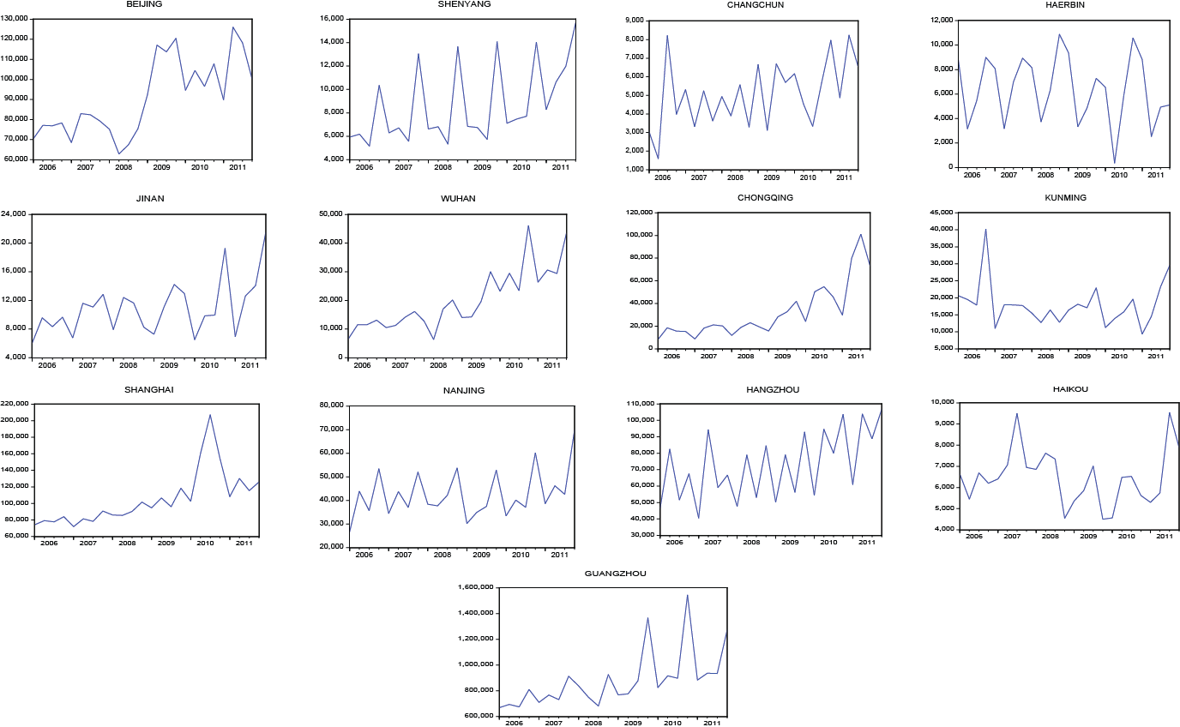

**Figure 1.** Inbound tourist arrivals of the 13 cities from Hong Kong.

Empirical Study

Sample Selection

The empirical study is based on a quarterly panel data set consisting of visitor flows from Hong Kong to Mainland China, which are clearly marked by seasonality. The territory of China is extremely large, with a wide range of latitude from north to south. Therefore, the country experiences significantly different climates across regions. When studying tourist flows between large regions (either domestically or internationally) with diverse climates, the tourist flows need to be disaggregated into regional flows based on the climate diversity before the climate index can be applied. The current study addresses this by looking into climatic variability across China and investigating 13 provincial capitals that are scattered throughout the country. The focus is on provincial capitals that attract a large number of Hong Kong visitors: Beijing, Shenyang, Changchun, Harbin, Shanghai, Nanjing, Hangzhou, Jinan, Wuhan, Guangzhou, Haikou, Chongqing, and Kunming.

The aforementioned 13 cities are chosen mainly for the following reasons. First, only 28 cities in the entire seasonal visitor arrivals data are available from the China National Tourism Administration website. Moreover, the China National Tourism Administration treats these cities as the most important and major inbound tourism reception cities. Second, among the 28 cities, only 13 cities have available tourism, economic (CPI), and climate data. Third, the 13 cities are distributed in the six of the total seven geographical divisions of Mainland China. However, among the aforementioned 28 cities, only Xi’an in Shanxi Province is located in Northwest China but climate data are not available for this city. Last, most of the 13 cities exhibit a significant seasonal pattern for visitor arrivals from Hong Kong (see Figure 1).

According to the Koppen climate classification system (primarily based on temperature and precipitation), Beijing, Shenyang, Changchun, Harbin, and Jinan belong to the humid continental climate (warm summer) zone, whereas Shanghai, Nanjing, Hangzhou, Wuhan, Guangzhou, Chongqing, and Kunming belong to the humid subtropical zone. Haikou belongs to the tropical wet (rainforest) zone. As Hong Kong belongs to the humid subtropical zone, we divided the 13 cities into two groups by climate similarity: group 1 has a similar climate as Hong Kong, including all the cities of the humid subtropical zone and Haikou, and group 2 has a climate largely different from Hong Kong, including all five cities in the humid continental climate (warm summer) zone.

Model Specifications

To estimate the effects of relative climate variability on tourism demand, a commonly used tourism demand model is augmented with the relative TCI based on a panel data of Hong Kong outbound tourism to the aforementioned two groups of destinations. Following Song et al. (2010, 2011) and Song and Lin (2010), the most important determinants considered of tourism demand are word-of-mouth effects, income of the origin countries, relative price, substitute price, and several dummy variables to determine the one-off events. Although marketing expenditures, travel costs, and holidays are expected to affect those tourists who are traveling to a specific destination from the source market, the data are either unavailable or difficult to measure (Goh, Law, and Mok 2008; Song and Lin 2010). In addition, several time-invariant, independent factors are neglected in panel data modeling, but this procedure does not affect the validity and consistency of the estimations (Falk 2010). The panel model can also reduce the possible omitted variable bias (Kuo et al. 2009). Following Song and Lin (2010), the variable of substitute price is neglected in this approach because of the complexity in identifying the substitute destinations for China’s various destinations. The current study uses the quarterly GDP per capita of Hong Kong as a proxy for the income variable, whereas the relative price is measured by the relative consumer price levels of Hong Kong tourists in their destination cities.

With the inclusion of the above variables, the following model is specified:

 (2)

where  is the visitor arrivals from Hong Kong to a specific city  in Mainland China at time ,  is the first-order lag of, and  is the GDP per capita of Hong Kong at time.  is the relative price, calculated based on , where  and  are *CPI*s of Hong Kong and the th destination city, respectively, at time; and  and  are the exchange rate indices for Hong Kong and the th destination city, respectively, at time.  is the relative climate difference for the th destination city at time .  is the deviation of *Rtci* from its long-term average.  refers to Beijing, Shenyang, Changchun, Harbin, Shanghai, Nanjing, Hangzhou, Jinan, Wuhan, Guangzhou, Haikou, Chongqing, or Kunming. The dummy variable of  refers to the possible effect of Global Financial Crisis (GFC) on visitor arrivals,  refers to the effect of 2008 Beijing Olympic Games, and  and  represent the possible influences of 2010 Shanghai Expo and 2010 Guangzhou Asian Games.  is the city-specific fixed effects and  is the error variance across regions and time.

From the literature review, the theoretical foundation of relative climate that affects tourism demand is based on the effects of destination climate, home climate, and destination and home climates on tourism demand. For comparison, we also added the destination and home climate indices separately and simultaneously to the tourism demand model in the current study. Therefore, the following three models are created based on equation (2):

 (2.1)

 (2.2)

 (2.3)

where  and  are the deviations of  and  from their long-term averages, where  is the climate TCI of destination *i* at time,  is the home climate TCI of Hong Kong at time. They are constructed as  and .

Since the lagged dependent variable  is included in the equations as an explanatory variable, traditional panel estimation methods may be biased and inconsistent (Nickell 1981). As a remedy, a number of dynamic panel estimators have been developed, such as the Arellano-Bond method (Arellano and Bond 1991) and the Blundell-Bond estimator (Blundell and Bond 1998). However, these approaches require a panel with large number of groups *N* and a relatively shorter time period *T*. In the case of a large *N* and a small *T*, it has been reported that the bias-corrected least-squares dummy variable (LSDV) estimator (Bruno 2005; Kiviet 1995) outperforms many other methods (Judson and Owen 1999). Since the sample in this study has a relatively larger *T* compared to *N*, the bias-corrected LSDV approach is employed to estimate the models.

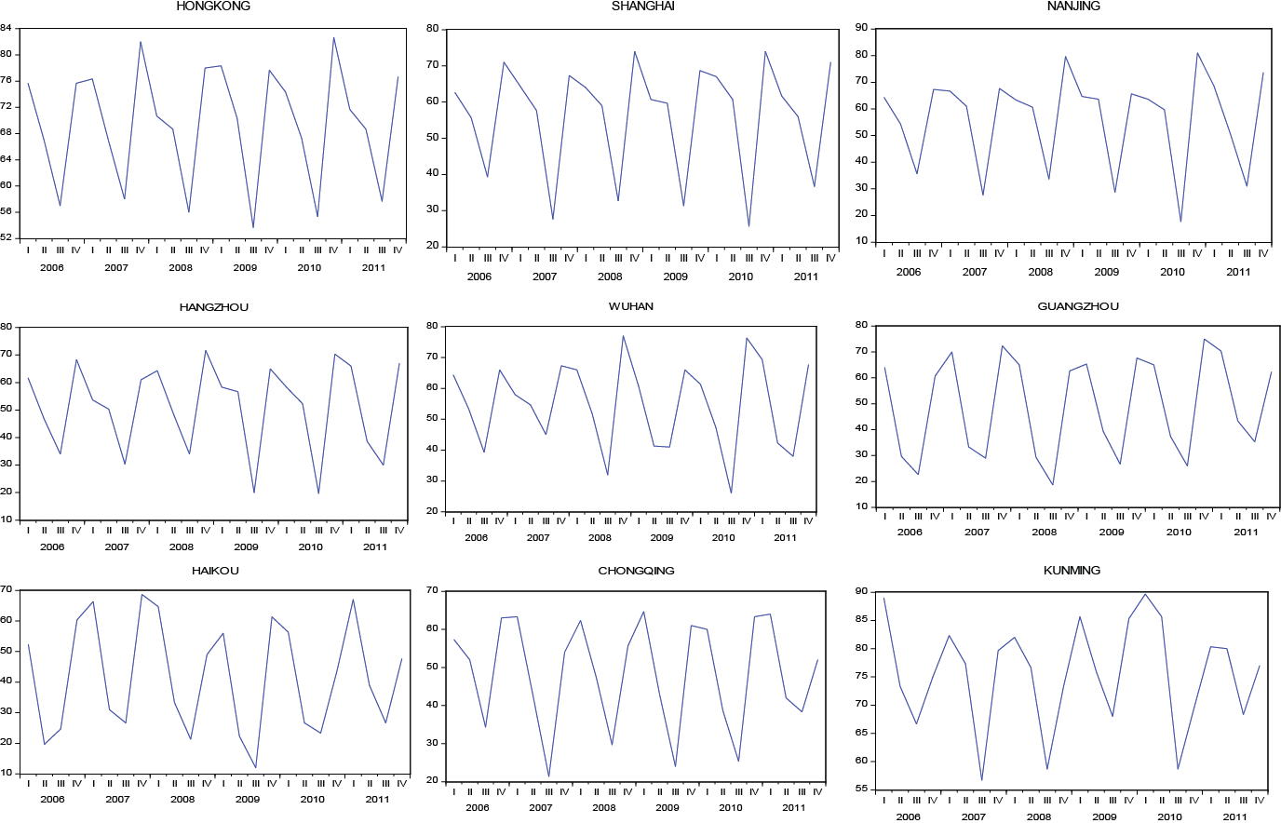

**Figure 2.** TCIs of Hong Kong and group 1 cities.

Data Source and Descriptive Statistics

The secondary data on the quarterly visitor arrivals are obtained from the China National Tourism Administration, and these secondary data are calculated based on visa information. This data type has several limitations. First, multidestination tourists are not captured in the data, which may result in the underestimation of visitor arrivals. Second, these data include both leisure- and business-oriented visitor arrivals. Disaggregated data are not available*.* The independent variables of Hong Kong GDP per capita (in US dollars), Hong Kong CPI, HKD to USD exchange rate, and RMB to USD exchange rate with 2005 as the benchmark year were obtained from the IMF International Financial Statistics Yearbook (2006–2011). The 13 cities’ CPIs were collected from the China Statistical Yearbook (2006–2011) through the CEIC China database, with 2005 as the benchmark year. Climatic data were obtained from the Hong Kong Observatory and China Meteorological Administration, respectively. The time frame (2006:Q01–2011:Q04) was selected as it was the longest time duration available when the study was conducted.

Figures 2 and 3 show the descriptive graphs for the seasonal variations of TCIs for both Hong Kong and other tourism destination cities (2006Q1–2011Q4). According to Figure 2, the fourth and first quarters are the most comfortable seasons for Hong Kong, followed by the second quarter, while the third quarter is the least comfortable season. Similarly, either the fourth or the first quarter is the most comfortable season for tourism in group 1 cities, and the third quarter is the least comfortable season. In contrast, regarding group 2 cities, Figure 3 shows that the second quarter has the most comfortable climate, while either the first (Haerbin, Changchun, and Shenyang) or the third (Beijing and Jinan) quarter is the least comfortable season for tourism.

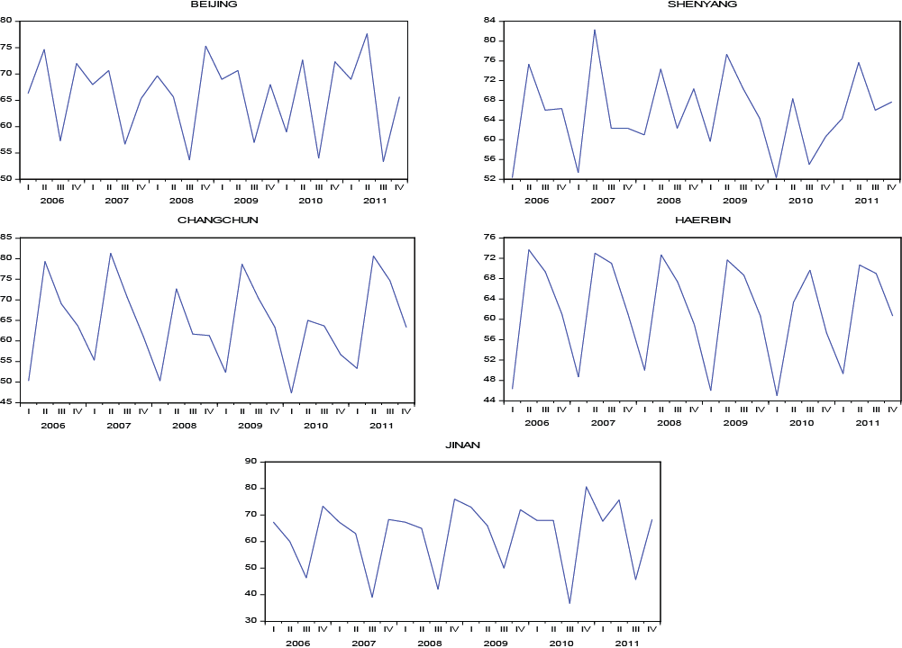

**Figure 3.** TCIs of group 2 cities.

Results

Based on the similarity/difference of climate between Hong Kong and the selected destinations, this study estimates models 2, 2.1, 2.2, and 2.3 for the aforementioned two groups of cities separately. Model 2 includes the relative climate variability in the tourism demand model. Models 2.1 and 2.2 include the destination and home climate variability separately in the tourism demand model, while model 2.3 includes destination and home climate variabilities simultaneously in the tourism demand model. The model estimation results are presented in Table 2. The estimation of model 2 shows that the coefficients of the control variables are largely consistent with prior studies. The first-order lag of tourism demand, representing the word-of-mouth effect, has a significantly positive effect for destinations in group 1 but nonsignificant for group 2. The income variable, that is, , shows a positive and significant effect on visitor arrivals for both groups. As expected, relative price negatively affects visitor arrivals in the both group 1 and group 2 cities, although the coefficient is not statistically significant for either group. In addition, the dummy of the 2010 Shanghai Expo has a significant positive effect on the tourism demand at destinations in group 1, whereas the 2010 Guangzhou Asian Games and the 2008 Beijing Olympic Games have nonsignificant effects for groups 1 and 2, respectively. The effect of GFC is statistically significant for group 1, while nonsignificant for group 2.

The empirical study focuses on the impact of relative climate variability on tourist arrivals as examined in model 2. It is found that for the group 1 cities, neither the intra-annual nor the interannual climate effect is significant, which implies that the generic TCI may not be able to explain the tourism demand for certain types of tourism or destinations. Seeking a distinct weather may not be a major motivation for tourists visiting the group 1 cities, which share similar climatic conditions with Hong Kong.

As for group 2, the coefficient of  suggests a significant intra-annual climate effect. In contrast to the results for group 1, the relative TCI significantly and positively affects visitor arrivals for group 2 cities, where the climate difference is an important motivation for Hong Kong tourists to travel to. An increase in the climate

**Table 2.** Bias-Corrected LSDV Estimation Results.

|  |  |  |  |  |  |  |  |  |
| --- | --- | --- | --- | --- | --- | --- | --- | --- |
| Variable | Group 1 | | | | Group 2 | | | |
|  | Model 2 | Model 2.1 | Model 2.2 | Model 2.3 | Model 2 | Model 2.1 | Model 2.2 | Model 2.3 |
|  | 0.318***  [0.320]  (5.40) | 0.322***  [0.324]  (5.04) | 0.327***  [0.329]  (5.33) | 0.325***  [0.327]  (4.97) | –0.027  [–0.025]  (–0.30) | –0.071  [–0.070]  (–0.78) | –0.070  [–0.068]  (–0.74) | –0.155*  [–0.155]  (–1.70) |
|  | 1.666***  [0.076]  (4.32) | 1.670***  [0.076]  (4.17) | 1.726***  [0.078]  (4.28) | 1.727***  [0.079]  (4.21) | 2.324***  [0.132]  (3.29) | 2.380***  [0.135]  (3.32) | 2.492***  [0.141]  (3.25) | 2.206***  [0.125]  (2.93) |
|  | –0.605  [–0.026]  (–1.61) | –0.661*  [–0.028]  (–1.69) | –0.577  [–0.024]  (–1.45) | –0.594  [–0.025]  (–1.46) | –0.235  [–0.014]  (–0.30) | –0.266  [–0.016]  (–0.33) | –0.152  [–0.009]  (–0.17) | –0.385  [–0.023]  (–0.45) |
|  |  | –0.053  [–0.015]  (–0.88) |  | –0.027  [–0.007]  (–0.23) |  | –0.555***  [–0.078]  (–2.17) |  | –0.676***  [–0.095]  (–2.69) |
|  |  | 0.002  [0.005]  (0.32) |  | 0.002  [–0.006]  (0.27) |  | –0.012  [–0.010]  (–0.30) |  | –0.008  [–0.007]  (–0.21) |
|  |  |  | –0.130  [–0.012]  (–0.77) | –0.062  [0.004]  (–0.19) |  |  | 0.427  [0.049]  (1.39) | 0.602*  [0.069]  (1.94) |
|  |  |  | –0.020  [–0.011]  (–0.86) | –0.020  [–0.011]  (–0.82) |  |  | 0.050  [0.034]  (1.03) | 0.052  [0.036]  (1.12) |
|  | –0.016  [–0.010]  (–0.58) |  |  |  | 0.127***  [0.105]  (2.66) |  |  |  |
|  | –0.005  [–0.004]  (–0.25) |  |  |  | –0.011  [–0.030]  (–0.97) |  |  |  |
|  | –0.145**  [–0.101]  (–2.33) | –0.143**  [–0.100]  (–2.35) | –0.157**  [–0.109]  (–2.50) | –0.156**  [–0.108]  (–2.44) | 0.022  [0.019]  (0.17) | –0.026  [–0.022]  (–0.20) | 0.009  [0.008]  (0.07) | 0.007  [0.006]  (0.05) |
|  |  |  |  |  | –0.286  [–0.248]  (–1.16) | –0.330  [–0.286]  (–1.31) | –0.285  [–0.247]  (–1.10) | –0.313  [–0.272]  (–1.23) |
|  | 0.322*  [0.223]  (1.84) | 0.302*  [0.209]  (1.75) | 0.310*  [0.215]  (1.78) | 0.302*  [0.210]  (1.73) |  |  |  |  |
|  | 0.314  [0.218]  (1.04) | 0.354  [0.247]  (1.18) | 0.368  [0.256]  (1.22) | 0.368  [0.256]  (1.22) |  |  |  |  |
| Observations | 176 | 176 | 176 | 176 | 110 | 110 | 110 | 110 |
| Groups | 8 | 8 | 8 | 8 | 5 | 5 | 5 | 5 |
| Observations per group | 22 | 22 | 22 | 22 | 22 | 22 | 22 | 22 |
| VIF range | [1.03, 1.49] | [1.01, 1.49] | [1.03, 1.49] | [1.03, 2.36] | [1.02, 1.48] | [1.07, 1.48] | [1.07, 1.60] | [1.09, 1.60] |

Note: Values in square brackets represent standardized coefficients (dummies are not standardized in the estimation). Values in parentheses indicate *Z*-ratios based on bootstrapped standard errors. VIF = variance inflation factor.

Coefficients are statistically significant at the *10%, **5%, and ***1% levels.

difference between the origin and these destinations from quarter to quarter will boost the tourism demand. The standardized coefficient shows that per standard deviation increase of  will lead to a rise of 10.50% standard deviation of the dependent variable . Compared with the coefficient of the income variable , which is commonly regarded as one of the most powerful determinants of tourism demand, it can be found that the relative climate index is relatively effective. On the other hand, the interannual effect is nonsignificant as indicated by the coefficient of . Tourists from Hong Kong may not consider the deviation of climate from the long-term trend as a major factor when choosing destinations. When other factors remain constant, a greater deviation of relative TCI from its long-term average would not attract additional tourism demand from Hong Kong.

For the purpose of comparison, models 2.1, 2.2, and 2.3 are estimated examining the impacts of destination and origin climate variables separately. The results for group 1 indicate that none of the destination and origin climate variables is statistically significant when they are added on top of the traditional economic variables across the three models. This finding is consistent with the results of model 2, where the effects of relative TCI are found to be nonsignificant for group 1.

In terms of group 2, the destination TCI exhibited a significantly negative intra-annual effect on visitor arrivals (model 2.1), while the home TCI was found to be nonsignificant (model 2.2), when they were tested separately. As the climates of destinations in group 2 are generally distinct from Hong Kong, it is suspected that the negative effect of the destination TCI could be explained by a travel motivation of seeking different climates. However, this finding has to be confirmed by controlling the effects of the origin TCI. When both the origin and the destination climate variables are introduced to the tourism demand model (model 2.3), their intra-annual effects are significant but with different signs. The effect of the origin TCI on visitor arrivals is positive whereas the destination TCI has a negative impact. In other words, the effects of climate variability at origins and destinations may be offset when they both move in the same direction. Hong Kong’s least comfortable season is the third quarter, which is also an uncomfortable tourism season in group 2 cities. Both Hong Kong and group 2 cities are hot, with extremely high temperatures. In contrast, Hong Kong’s most comfortable climate occurs in the first and fourth quarters when group 2 destinations experience a colder winter. Although the climate in these cities is not perceived as comfortable, it is ideal for winter activities, which is quite attractive for Hong Kong residents to escape from the humid subtropical climate. Therefore, it suggests that seeking novelty in climate is one of the motivations for Hong Kong tourists to visit group 2 cities. This confirms the finding that it is the difference in the climate conditions between origins and destinations that influences tourist arrivals.

Comparatively, the intra-annual effect of the destination TCI on visitor arrivals is more significant than the home TCI. In other words, the climatic pull factor is more influential than the push factor in tourists’ decision making. The standardized coefficients indicate that when  increases by one standard deviation, the dependent variable will decrease by 9.50% standard deviation, while 6.90% standard deviation of the dependent variable will increase for every standard deviation increase in .

Similar to the results for group 1, the interannual effects of both the home and destination climate variables were found to be nonsignificant across the three models for the group 2 cities. This confirms that compared to the effects of climate deviations from a long-term trend, the changes of relative climate from quarter to quarter is a more important factor in tourists’ travel decision making.

Discussion and Conclusion

Seasonal demand variation in tourism is an important theme in literature, and it also has major implications for tourism industry management and policy making (Koenig-Lewis and Bischoff 2005). However, seasonal tourism demand has been inadequately investigated, especially from the climate variability perspective. The primary contribution of the present study is to construct a relative climate index and to test its intra- and interannual effects on seasonal visitor arrivals, based on a quarterly panel data set. Similar to relative tourism price, perception of the climate comfort level is treated in relative terms. The empirical study illustrates the effectiveness of the proposed approach with a sample consisting of Hong Kong as the origin and 13 Mainland Chinese cities as destinations.

China has become one of the world’s top three tourist destinations, in which approximately half of the visitor arrivals are from Hong Kong. This study tests the impact strength of the climate variable on tourism demand in two regions in Mainland China, which were divided based on climate similarity with Hong Kong. The empirical results show that the relative climate between the home and destination climates is an important determinant of tourism demand seasonality in regions where the climate is significantly different from that of Hong Kong. However, the effect of relative climate has a nonsignificant effect in regions where the climate is similar to that in Hong Kong. This result indicates that relative climate positively affects the tourism demand of Hong Kong for group 2 cities in Mainland China. Therefore, the larger the difference between the home and destination climates, the more likely Hong Kong tourists would visit the sampled city. Tourism studies should focus more on the climate effects of origin and destination markets simultaneously in various seasons because more tourists may be motivated to select destinations with climates different from their home climate.

It has been found in the literature that climate is a driver for tourism demand. This study furthers this understanding by examining the intra- and interannual effects of relative climate variability. The results suggest that relative TCI is a significant motivation for tourists to travel to destinations where the climate conditions are distinct from Hong Kong. Underpinned by a significant intra-annual climate effect, the seasonality of tourism demand at these destinations can be partly explained by the relative climate difference from season to season. However, a nonsignificant interannual climate effect suggests that tourism demand is unlikely to be affected by the deviation of relative TCI from its long-term average. Tourists’ travel decision is mainly determined by the relative intra-annual seasonality. When other factors including the relative climate index remain unchanged, an abnormally large climate deviation from the long-term trend does not contribute to extra tourism demand. This finding seems counterintuitive as earlier research found that a particularly wet or a particularly warm month might cause less than, or greater than, normal tourist arrivals (Agnew and Palutikof 2001; Dawson, Scott, and McBoyle 2009; Serquet and Rebetez 2011). However, this finding of the current study actually further explains that the observed change in tourism demand is fundamentally caused by a greater climate difference instead of the deviation itself. In reality, when there is a large deviation of climate from average years in a destination, it is likely to generate a large climate difference in this particular season. Tourists are therefore more likely to visit this destination. But this positive impact is contributed by the intra-annual effect. On the other hand, when the relative climate index is controlled, that is, the relative climate difference between destination and origin remains constant, a deviance of climate condition in the destination or the origin from its long-term trend would not influence tourists’ travel decision; thus the arrivals would not be affected. This implies that tourists would make destination choice based on the climate difference between origin and destination, while how much the climate condition of destination or origin drifts from the long-term trend would not be considered in the tourists’ decision-making process.

Therefore, planners in the tourism industry must estimate the effect of climate, specifically that of the climate similarities/differences between the origin and the destination, on seasonal tourism demand. On the one hand, tourism planners and marketers in the group 1 cities, including Shanghai, Nanjing, Hangzhou, Wuhan, Guangzhou, Chongqing, Kunming, and Haikou, may disregard the differences in the climate of the origin and destination when they target the Hong Kong market. On the other hand, tourism practitioners in the group 2 cities, including Beijing, Shenyang, Changchun, Harbin, and Jinan, should focus on both destination climate and climate of the target markets as important drivers for pulling and pushing tourists away from Hong Kong. Moreover, tourism practitioners need to attach importance to the effects of relative climate effects because novelty in climate is a motivation to travel. Therefore, a distinct climate rather than a comfortable climate should be highlighted in destination promotions to attract tourists from the source region. Understanding the impact of climate is also critical in policy design. Timing, location, and market segmentation used for marketing campaigns get lots of benefits from a more comprehensive understanding of the climate influence. Moreover, the approach used in this current study also allows for the applications under other alternative scenarios of climate variation or change.

While the proposed approach shows its usefulness, limitations of this study should be noted. The insignificant effects of relative climate index for group 1 destinations suggest that this approach may only be effective for destination–origin pairs located in different climatic types. Moreover, when analyzing tourist flows between larger regions with diverse climates, the origin and destinations need to be divided into smaller regions based on climate diversity before the proposed approach can be applied. In the empirical study, only 13 major Chinese cities are selected as sample destinations as a result of data unavailability. The data used in this study include both leisure- and business-oriented visitor arrivals. Multidestination tourists also are not captured in the data. However, as Nunes and colleagues (2013) suggested, the effects of climate on tourism demand may vary in different types of destinations (e.g., arts and business, hills and countryside, seas, and mountains). Additionally, the relative price is found to be nonsignificant in the sampled origin–destination pairs, which may not be the case in other contexts. Therefore, it is worth investigating further the effects of relative climate on seasonal tourism demand in different types of destinations and origins in future studies.

Declaration of Conflicting Interests

The author(s) declared no potential conflicts of interest with respect to the research, authorship, and/or publication of this article.

Funding

The author(s) received no financial support for the research, authorship, and/or publication of this article.

References

Agnew, M. D., and J. P. Palutikof. 2006. “Impacts of Short-term Climate Variability in the UK on Demand for Domestic and International Tourism.” *Climate Research* 31 (1): 109–20.

Amelung, B., S. Nicholls, and D. Viner. 2007. “Implications of Global Climate Change for Tourism Flows and Seasonality.” *Journal of Travel Research* 45 (3): 285–96.

Arellano, M., and S. Bond. 1991. “Some Tests of Specification for Panel Data: Monte Carlo Evidence and an Application to Employment Equations.” *Review of Economic Studies* 58 (2): 277–97.

Baron, R. R. V. 1975. *Seasonality in Tourism: A Guide to the Analysis of Seasonality and Trends for Policy Making*. London, UK: Economist Intelligence Unit.

Baum, T., and S. Lundtorp. 2001. *Seasonality in Tourism*. Oxford, UK: Pergamon.

Becken, S. 2013. “Measuring the Effect of Weather on Tourism: A Destination- and Activity-Based Analysis.” *Journal of Travel Research* 52 (2): 156–67.

Berrittella, M., A. Bigano, R. Roson, and R. S. Tol. 2006. “A General Equilibrium Analysis of Climate Change Impacts on Tourism.” *Tourism Management* 27 (5): 913–24.

Bigano, A., A. Goria, J. Hamilton, and R. S. Tol. 2005. “The Effect of Climate Change and Extreme Weather Events on Tourism.” In *The Economics of Tourism and Sustainable Development*, edited by A. Lanza, A. Markandya, and F. Pigliaru, 173–90. Cheltenham, UK: Edward Elgar.

Bigano, A., J. M. Hamilton, and R. S. Tol. 2006. “The Impact of Climate on Holiday Destination Choice.” *Climatic Change* 76 (3): 389–406.

Blundell, R., and S. Bond. 1998. “Initial Conditions and Moment Restrictions in Dynamic Panel Data Models.” *Journal of Econometrics* 87 (1): 115–43.

Bruno, G. S. F. 2005. “Approximating the Bias of the LSDV Estimator for Dynamic Unbalanced Panel Data Models.” *Economics Letters* 87 (3): 361–66.

Butler, R. W. 1994. “Seasonality in Tourism: Issues and Problems.” In *Tourism: The State of the Art*, edited by A. V. Seaton, 332–39. Chichester, UK: Wiley.

China National Tourism Administration. 2013. CEIC China Database. Accessed May 12, 2013.

China Statistical Yearbook. 2006–2011. CEIC China Database. Accessed May 12, 2013.

Dawson, J., D. Scott, and G. McBoyle. 2009. “Climate Change Analogue Analysis of Ski Tourism in the Northeastern USA.” *Climate Research* 39 (1): 1–9.

Denstadli, J. M., J. K. S. Jacobsen, and M. Lohmann. 2011. “Tourist Perceptions of Summer Weather in Scandinavia.” *Annals of Tourism Research* 38 (3): 920–40.

de Freitas, C. R. 2003. “Tourism Climatology: Evaluating Environmental Information for Decision Making and Business Planning in the Recreation and Tourism Sector.” *International Journal of Biometeorology* 48 (1): 45–54.

de Freitas, C. R. 2005. “The Climate-Tourism Relationship and Its Relevance to Climate Change Impact Assessment.” In *Tourism, Recreation and Climate Change*, edited by C. M. Hall and J. E. Higham, 29–43. Clevedon, UK: Channel View.

de Freitas, C. R., D. Scott, and G. McBoyle. 2004. “A New Generation Climate Index for Tourism and Recreation.” In *Advances in Tourism Climatology*, edited by A. Matzarakis, C. R. de Freitas, and D. Scott, 19–27. Freiburg, Germany: Berichte des Meteorologischen Institutes der Universität Freiburg.

de Freitas, C. R., D. Scott, and G. McBoyle. 2008. “A Second Generation Climate Index for Tourism (CIT): Specification and Verification.” *International Journal of Biometeorology* 52 (5): 399–407.

Eugenio-Martin, J. L., and J. A. Campos-Soria. 2010. “Climate in the Region of Origin and Destination Choice in Outbound Tourism Demand.” *Tourism Management* 31 (6): 744–53.

Falk, M. 2010. “A Dynamic Panel Data Analysis of Snow Depth and Winter Tourism.” *Tourism Management* 31 (6): 912–24.

Frechtling, D. C. 1996. *Practical Tourism Forecasting*. Oxford, UK: Butterworth-Heinemann.

Goh, C. 2012. “Exploring Impact of Climate on Tourism Demand.” *Annals of Tourism Research* 39 (4): 1859–83.

Goh, C., R. Law, and H. M. Mok. 2008. “Analyzing and Forecasting Tourism Demand: A Rough Sets Approach.” *Journal of Travel Research* 46 (3): 327–38.

Hadwen, W. L., A. H. Arthington, P. I. Boon, B. Taylor, and C. S. Fellows. 2011. “Do Climatic or Institutional Factors Drive Seasonal Patterns of Tourism Visitation to Protected Areas across Diverse Climate Zones in Eastern Australia?” *Tourism Geographies* 13 (2): 187–208.

Hamilton, J. M., D. J. Maddison, and R. S. Tol. 2005. “Climate Change and International Tourism: A Simulation Study.” *Global Environmental Change* 15 (3): 253–66.

Hsiao, C. 2003. *Analysis of Panel Data*, 2nd ed. Cambridge: Cambridge University Press.

IMF International Financial Statistics Yearbook. 2006–2011. DataStream Database. Accessed May 12, 2013.

Jacobsen, J. K. S. 2001. “Nomadic Tourism and Fleeting Place Encounters: Exploring Different Aspects of Sightseeing.” *Scandinavian Journal of Hospitality and Tourism* 1 (2): 99–112.

Judson, R. A., and A. L. Owen. 1999. “Estimating Dynamic Panel Data Models: A Guide for Macroeconomists.” *Economics Letters* 65 (1): 9–15.

Kiviet, J. F. 1995. “On Bias, Inconsistency, and Efficiency of Various Estimators in Dynamic Panel Data Models.” *Journal of Econometrics* 68 (1): 53–78.

Koenig-Lewis, N., and E. E. Bischoff. 2005. “Seasonality Research: The State of the Art.” *International Journal of Tourism Research* 7 (4/5): 201–19.

Kulendran, N., and L. Dwyer. 2012. “Modeling Seasonal Variation in Tourism Flows with Climate Variables.” *Tourism Analysis* 17 (2): 121–37.

Kuo, H. I., C. L. Chang, B. W. Huang, C. C. Chen, and M. McAleer. 2009. “Estimating the Impact of Avian Flu on International Tourism Demand Using Panel Data.” *Tourism Economics* 15 (3): 501–11.

Lee, T. H., and J. Crompton. 1992. “Measuring Novelty Seeking in Tourism.” *Annals of Tourism Research* 19 (4): 732–51.

Li, H., Song, H., and L. Li. 2016. “A Dynamic Panel Data Analysis of Climate and Tourism Demand: Additional Evidence.” *Journal of Travel Research*. Published online August 4. doi: 0047287515626304.

Lim, C., and M. McAleer. 2001. “Cointegration Analysis of Quarterly Tourism Demand by Hong Kong and Singapore for Australia.” *Applied Economics* 33 (12): 1599–1619.

Maddison, D. 2001. “In Search of Warmer Climates? The Impact of Climate Change on Flows of British Tourists.” *Climatic Change* 49 (1): 193–208.

Mieczkowski, Z. 1985. “The Tourism Climatic Index: A Method of Evaluating World Climates for Tourism.” *Canadian Geographer/Le Géographe Canadien* 29 (3): 220–33.

Moore, W. R. 2010. “The Impact of Climate Change on Caribbean Tourism Demand.” *Current Issues in Tourism* 13 (5): 495–505.

Nickell, S. 1981. “Biases in Dynamic Models with Fixed Effects.” *Econometrica* 49 (6): 1417–26.

Nunes, P. A., M. Cai, R. Ferrise, M. Moriondo, and B. Marco. 2013. “An Econometric Analysis of Climate Change Impacts on Tourism Flows: An Empirical Evidence from the Region of Tuscany, Italy.” *International Journal of Ecological Economics and Statistics* 31 (4): 1–20.

Pearce, D. G. 1987. *Tourism Today. A Geographical Analysis*. New York: Wiley.

Ridderstaat, J., M. Oduber, R. Croes, P. Nijkamp, and P. Martens. 2014. “Impacts of Seasonal Patterns of Climate on Recurrent Fluctuations in Tourism Demand: Evidence from Aruba.” *Tourism Management* 41:245–56.

Saverimuttu, V., and M. E. Varua. 2014. “Climate Variability in the Origin Countries as a ‘Push’ Factor on Tourist Arrivals in the Philippines.” *Asia Paciﬁc Journal of Tourism Research* 19 (7): 846–57.

Scott, D., G. McBoyle, and M. Schwartzentruber. 2004. “Climate Change and the Distribution of Climatic Resources for Tourism in North America.” *Climate Research* 27 (2): 105–17.

Serquet, G., and M. Rebetez. 2011. “Relationship between Tourism Demand in the Swiss Alps and Hot Summer Air Temperatures Associated with Climate Change.” *Climatic Change* 108 (1-2): 291–300.

Song, H., and S. Lin. 2010. “Impacts of the Financial and Economic Crisis on Tourism in Asia.” *Journal of Travel Research* 49 (1): 16–30.

Song, H., S. Lin, S. F. Witt, and X. Zhang. 2011. “Impact of Financial/economic Crisis on Demand for Hotel Rooms in Hong Kong.” *Tourism Management* 32 (1): 172–86.

Song, H., S. Lin, X. Zhang, and Z. Gao. 2010. “Global Financial/Economic Crisis and Tourist Arrival Forecasts for Hong Kong.” *Asia Pacific Journal of Tourism Research* 15 (2): 223–42.

Taylor, T., and R. A. Ortiz. 2009. “Impacts of Climate Change on Domestic Tourism in the UK: A Panel Data Estimation.” *Tourism Economics* 15 (4): 803–12.

Yu, G., Z. Schwartz, and J. E. Walsh. 2010. “Climate Change and Tourism Seasonality.” *Journal of Tourism* 11 (2): 51–65.

Zhang, H. Q., and N. Kulendran. 2016. “The Impact of Climate Variables on Seasonal Variation in Hong Kong Inbound Tourism Demand.” *Journal of Travel Research*. Published online January 14. doi:0047287515619692.

Zhou-Grundy, Y., and L. W. Turner. 2014. “The Challenge of Regional Tourism Demand Forecasting: The Case of China.” *Journal of Travel Research* 53 (6): 747–59.

Author Biographies

**Hengyun Li** is a PhD candidate and research assistant in the SmartState Center of Economic Excellence in Tourism and Economic Development, School of Hotel, Restaurant and Tourism Mangement, at the University of South Carolina, Columbia, USA.

**Carey Goh** is assistant professor of tourism in the School of Hotel and Tourism Management at The Hong Kong Polytechnic University, Hong Kong SAR, China.

**Kam Hung** is associate professor of tourism in the School of Hotel and Tourism Management at The Hong Kong Polytechnic University, Hong Kong SAR, China.

**Jason Li Chen** is lecturer of tourism and events management in the School of Hospitality and Tourism Management, Faculty of Arts and Social Sciences, at the University of Surrey, United Kingdom.